Forecasting number of airline passengers based on historical data

Introduction:
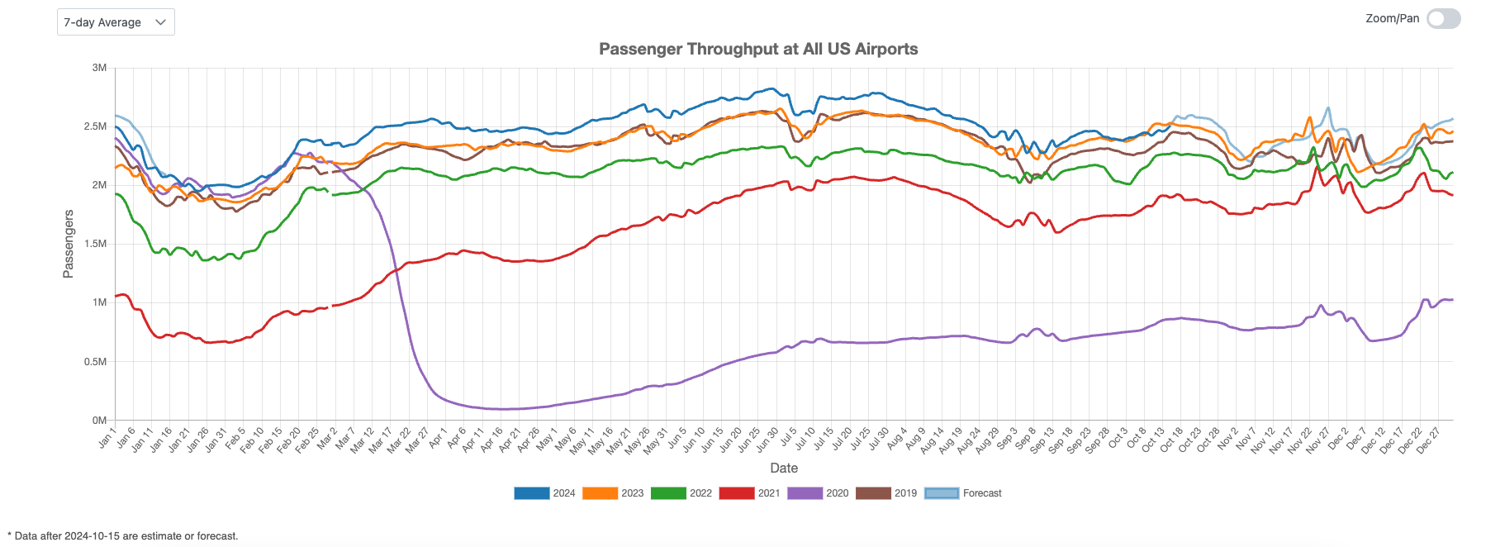
COVID had a major impact on air travel in 2020. Just a year earlier, roughly 2.5 million people relied on air travel daily, but that number plummeted during the pandemic. It took 3–4 years for passenger levels to return to 2019 figures.

A forecasting model predicting this recovery would have given airlines a significant advantage in planning financial investments, managing manpower, improving airport services, and reducing operational risks.

Objective
The dataset used for analysis is a simplistic data containing the number of passengers per month from the 1949-1960 time period. Using the historical data timeseries modelling could be likely to forecast passengers counts at a future interval. The final model would be selected based on their RMSE and/or AIC scores.

Methodology:

Data Wrangling:
The historical data was looked for common data issues. The heatmap (with annotations) helped us ascertain there were no missing time periods or duplicate data.
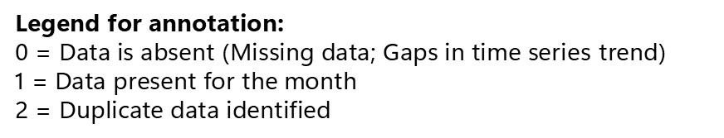
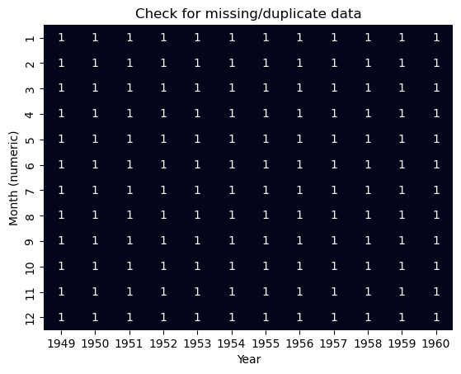

Further, the timeseries was plotted as a line plot to see the trend of data and to identify outliers in it. The plot shows a steady upward growth and the repeated spikes every 12 months indicate seasonality.
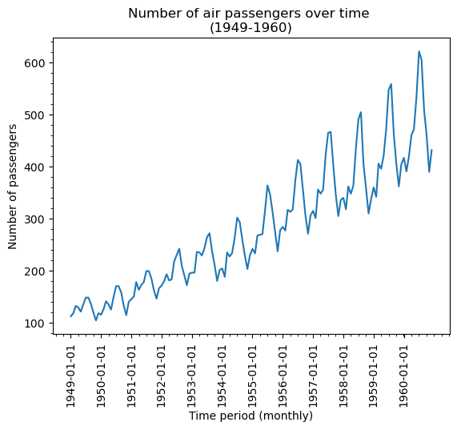

Data Exploration:
Decomposition is a primary step in Time series analysis. The series can be broken down into these 3 factors/components:
- Trend: Steady growth observed in number of passengers
- Seasonality: 12-month seasonal effect evident in data
- Residuals/Error: Additive model leaves behind remnants of a pattern even after decomposition. On the other hand residuals from a multiplicative model is very flat.
Multiplicative model was thus chosen for decomposition of time series!

ACF and PACF plots
- Gradual decline observed which suggests a long-term dependency (i.e. past values have a prolonged effect).
- Presence of many significant values indicating non-stationarity.
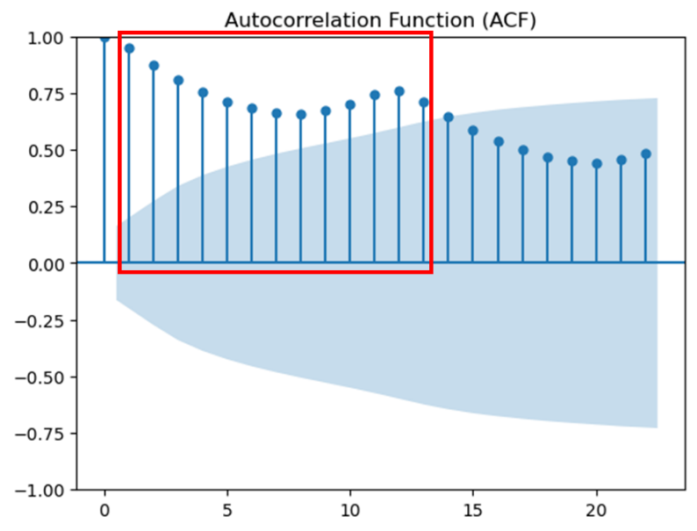
- Likely requires lag(2) or AR(2) model (i.e. possibly p=2).
- Isolated significant values at certain lags (1, 2, 9 & 13) marks them as important predictors for the current value.
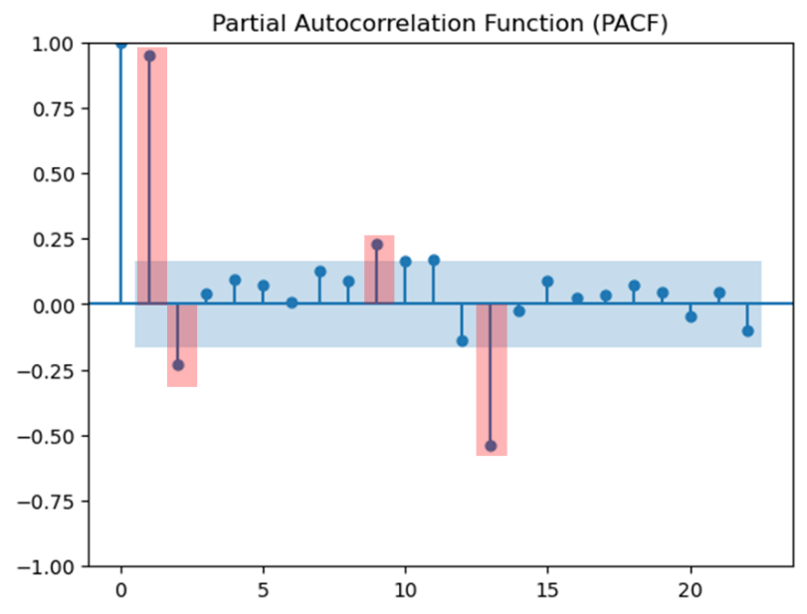

Modelling:
Due to absence of additional features, there no standardization or encoding to be done on data

  - ARIMA (AutoRegressive integrated moving average)

ADF Test: Test to find order of differencing. This wpould help cut down values to be used in hyper parameter tuning (p, d, q) order for ARIMA.
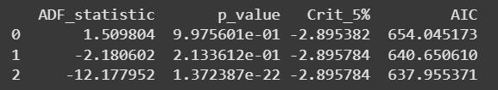
p-value for 1st order of differencing falls under 0.05 (95% CI). Thus, at least a 1st order of differencing is required for data (or d=1 or higher).
Hyper parameter tuning identifies (0, 2, 1) to give the best RMSE score. AIC score was discarded as a potential scoring method due to the inefficiency of ARIMA on seasonal data.
Besides (p, d, q) ARIMA has one other parameter worth testing: ‘Trend’ (=n, c, t or ct).But since only the default trend option is applicable to data (trend=’n’ or No trend),
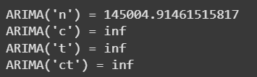
Plotting the predicted values against the original data, we get…
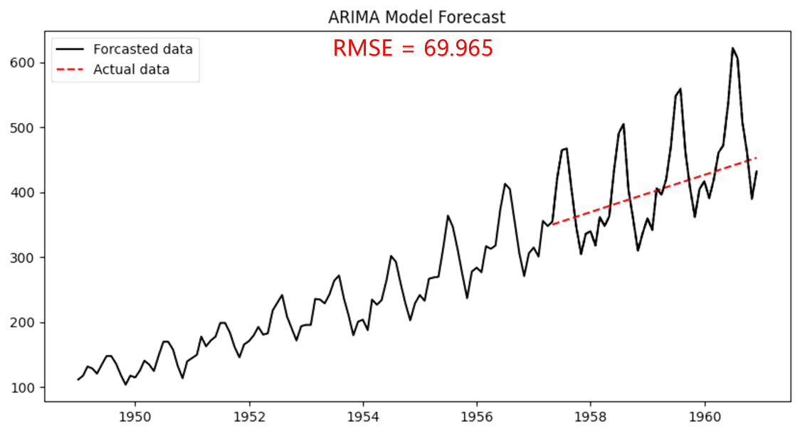

  - SARIMA (Seasonal ARIMA):
SARIMA works similar to ARIMA but with an added feature of seasonality. Continuing the ADF test from ARIMA modelling,
CASE 1: When d=2
p-value (D=0) < 0.05 (i.e Null hypothesis rejected & data is stationary). Thus, for d=2, D=0 is acceptable
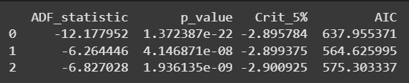

CASE 2: When d=1
p-value (D=1) < 0.05 (i.e Null hypothesis rejected & data is stationary). Thus for d=1, D=1 is acceptable.
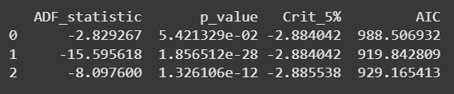
Hyper parameter testing is used to determine the other SARIMA parameters, namely p, q, P & Q. m=12 since seasonality was observed to repeat every 1 year.
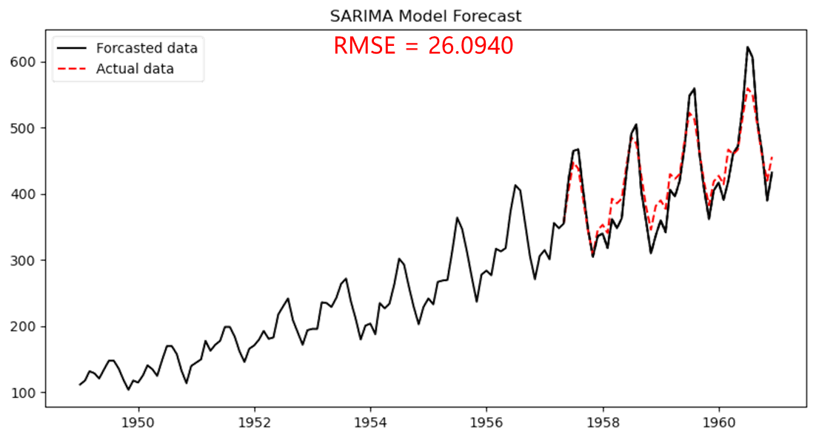

  - LSTM (Long Short Term Memory)
Reshape Data: Unlike the previous two models, LSTM is a Neural network that functions as a regressor model. Thus the data needs reshaping to meet its unique criterias
- LSTM sequences - the input layer expects a 3D array of data when fitting the model in the shape of [samples, time steps, features]
- Since it’s a regressor model, its expects data in the form of input – output pairs. The historical data was thus discarded and restricted such that past 10 values serving as input for forecasting the current value.

LSTM structure:
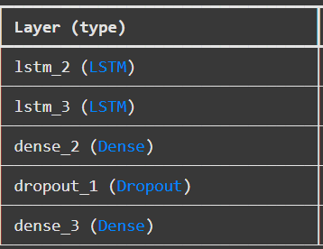

The number of nodes in 1st and 2nd layer were hyperparameter tested for best RMSE score. Dropout was set at 60% since LSTM is highly prone to overfitting.


Performance Metric:
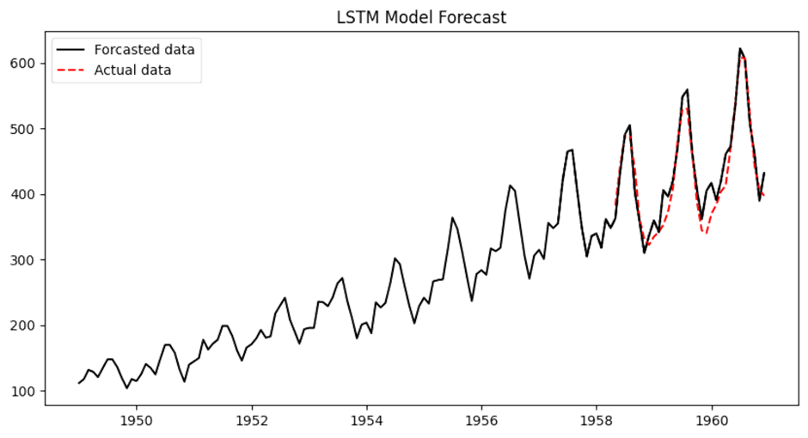
RMSE = 25.04
Loss from training and test was calculated and plotted to test for over/under-fitting data.
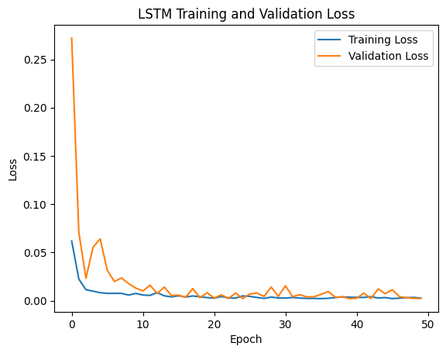
The plot shows training and validation loss that decreases to a point of stability with a minimal gap between the two final loss values, indicating a good fit! Th RMSE score for test is not too farther away from test, which is more evidence for not overfitting!
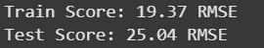
Conclusion: LSTM with its long term dependencies are a perfect for the data with least RMSE score

